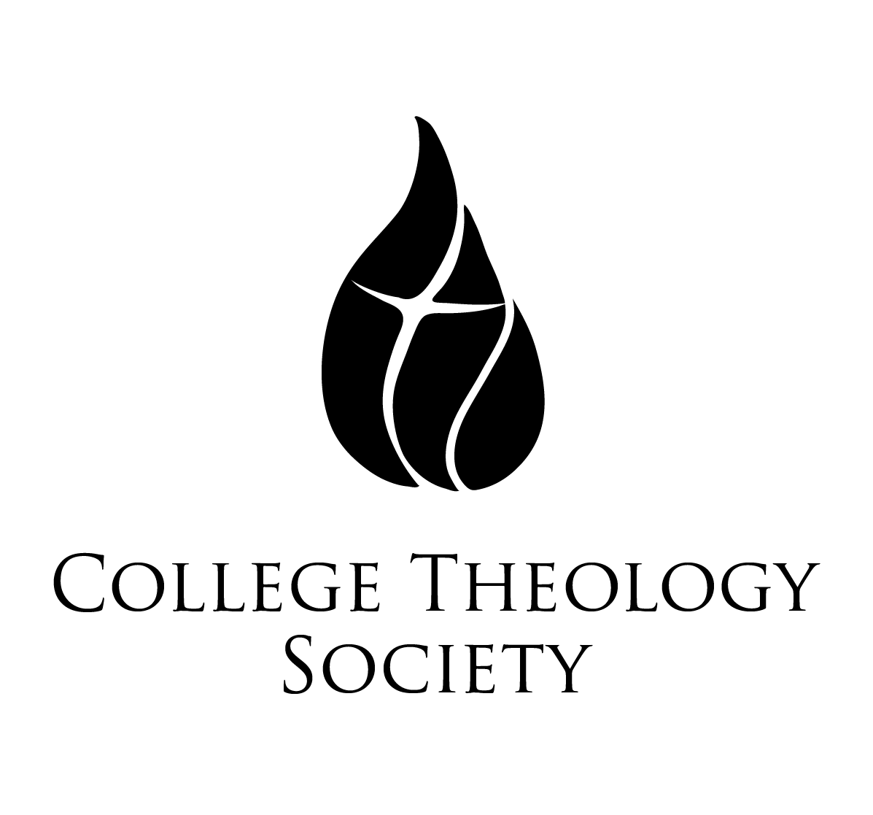 | Father David Gentry-Akin, M.Div., STL, STD  Executive Director of National Conventions  College Theology Society  Saint Mary’s College of California  1928 Saint Mary’s Road, PMB 3058  Moraga, CA 94575-2715  collegetheology.org  dgentry@stmarys-ca.edu  925.631.4790
Sixty-Fifth Annual Convention
Holy Cross College at Notre Dame, South Bend, Indiana
Thursday, May 30-Sunday, June 2, 2019
Book Exhibitor Form

Please return this form via email or hard copy to the above address no later than May 1, 2019.

Name:

Publishing House:

E-Mail Address:

Telephone:

How Many Tables Will You Need?

Anything Else That It Would Be Helpful For Us to Know:

At the close of the convention, please

Return any unsold books to us, using the prepaid, self-addressed mailing labels that our representatives will provide before they leave South Bend.

Donate any unsold books to the Holy Cross College library, with an acknowledgment of your gift to be sent to the address below

