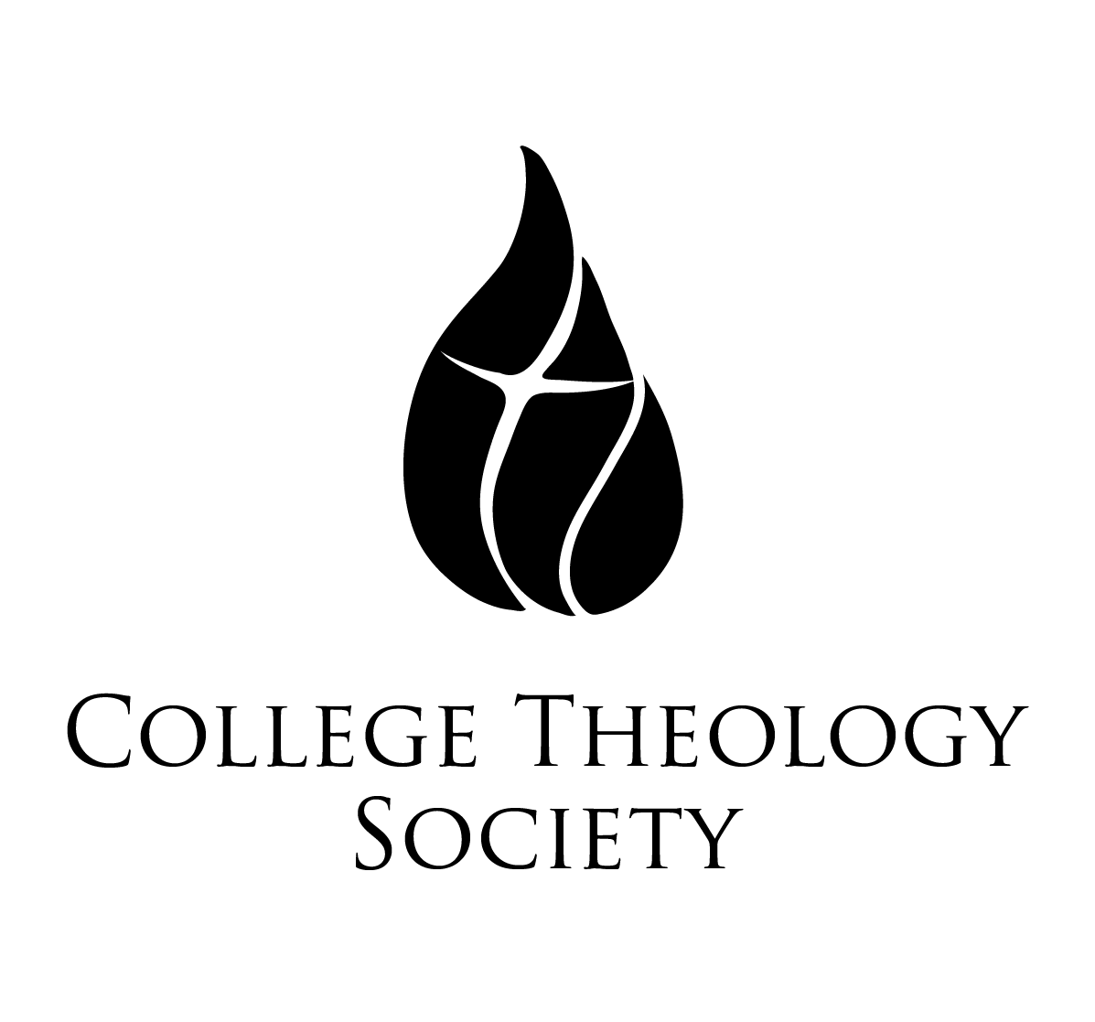 | David Gentry-Akin, M.Div., STL, STD  Executive Director of National Conventions  College Theology Society  Saint Mary’s College of California  1928 Saint Mary’s Road, PMB 3058  Moraga, CA 94575-2715  collegetheology.org  dgentry@stmarys-ca.edu  925.631.4790
Sixty-Third Annual Convention
Salve Regina University, Newport, Rhode Island
Thursday, June 1-Sunday, June 4, 2017
Book Exhibitor Form

Please return this form via email or hard copy to the above address no later than May 1, 2017.

Name:

Publishing House:

E-Mail Address:

Telephone:

How Many Tables Will You Need?

Anything Else That It Would Be Helpful For Us to Know:

At the close of the convention, please

Return any unsold books to us, using the prepaid, self-addressed mailing labels that our representatives will provide before they leave Portland.

Donate any unsold books to the Salve Regina University library, with an acknowledgment of your gift to be sent to the address below

